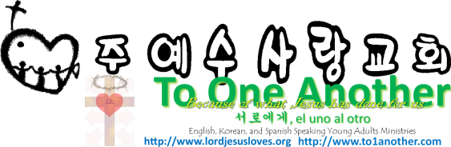
Ministry from Bottom Up
Pastor Yoo Nam Kang
Ephesians 4:16
March 3, 2013
Scriptures in New Living Translation

Ephesians 4:16
From him the whole body, joined and held together by every supporting ligament, grows and builds itself up in love, as each part does its work.
1Corinthians 11:3
But I want you to realize that the head of every man is Christ, and the head of the woman is man,[a] and the head of Christ is God.
Ephesians 1:10
to be put into effect when the times reach their fulfillment—to bring unity to all things in heaven and on earth under Christ.

1. Church Node (Relationship Between the Pastor and the Congregation)
Hebrews:13:17
Have confidence in your leaders and submit to their authority, because they keep watch over you as those who must give an account. Do this so that their work will be a joy, not a burden, for that would be of no benefit to you.
John 13:20
Very truly I tell you, whoever (congregation) accepts anyone I send (disciples, apostles) accepts me (Jesus); and whoever accepts me accepts the one who sent me (God).”
John 6:63
The Spirit alone gives eternal life. Human effort accomplishes nothing. And the very words I have spoken to you are spirit and life.
Hebrews 13:7
Remember your leaders who taught you the word of God. Think of all the good that has come from their lives, and follow the example of their faith.
Ephesians 4:16
He makes the whole body fit together perfectly. As each part does its own special work, it helps the other parts grow, so that the whole body is healthy and growing and full of love.
Ephesians 4:13
This will continue until we all come to such unity in our faith and knowledge of God’s Son that we will be mature in the Lord, measuring up to the full and complete standard of Christ.

2. Small Group Node
1 Corinthians 16:19
The churches here in the province of Asia send greetings in the Lord, as do Aquila and Priscilla and all the others who gather in their home for church meetings.
Acts 5:42
And every day, in the Temple and from house to house, they continued to teach and preach this message: “Jesus is the Messiah.”
John 5:19-21
19 So Jesus explained, “I tell you the truth, the Son can do nothing by himself. He does only what he sees the Father doing. Whatever the Father does, the Son also does. 20 For the Father loves the Son and shows him everything he is doing. In fact, the Father will show him how to do even greater works than healing this man. Then you will truly be astonished. 21 For just as the Father gives life to those he raises from the dead, so the Son gives life to anyone he wants.

3. Family Node
Ephesians 5:22, 25
22 For wives, this means submit to your husbands as to the Lord. 25 For husbands, this means love your wives, just as Christ loved the church. He gave up his life for her
Romans 9:3
for my people, my Jewish brothers and sisters. I would be willing to be forever cursed—cut off from Christ!—if that would save them.
Exodus 32:32
But now, if you will only forgive their sin—but if not, erase my name from the record you have written!”
Ephesians 6:1, 4
1 Children, obey your parents because you belong to the Lord, for this is the right thing to do. 4 Fathers, do not provoke your children to anger by the way you treat them. Rather, bring them up with the discipline and instruction that comes from the Lord.
1Corinthians 15:10
But whatever I am now, it is all because God poured out his special favor on me—and not without results. For I have worked harder than any of the other apostles; yet it was not I but God who was working through me by his grace.

